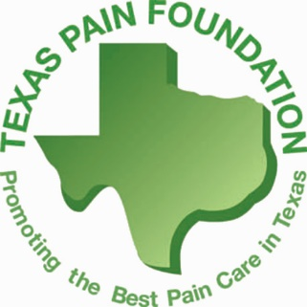
6th Annual Resident Scholarship
SCIENTIFIC MEETING SCHOLARSHIP APPLICATION
DUE 10/12/2018

2018 Scholarship Application

Instructions
Eligibility: All Texas residents in any specialty are eligible to apply.

Please complete the questions below entirely. You may attach an additional page if you need more space. Return the form to Krista DuRapau at Texas Pain Society no later than October 12, 2018 by email at kdurapau@texaspain.org or fax (866) 235-2557 or PO Box 201363, Austin, TX 78720. Questions? Call 512-535-0010.

Once received, the Texas Pain Society Board of Directors will review the applications and choose five (5) residents to receive the scholarship. The scholarship will allow a complimentary registration for the full meeting weekend. Residents will be responsible for travel and hotel accommodations.

Resident Contact Information
Name:
Email and/ or Phone:
Address: |  |  | City/State/Zip:
School/ Program:
Estimated Completion Date:

Short Answer Questions (please use additional pages if necessary)
What do you hope to learn from attending the TPS 10th Annual Scientific Meeting:

What made you interested in pain medicine:

